K.L.E. Society’s

Lingaraj College, Belagavi
(Autonomous)
Degree Examinations June/July 2021

Toppers in the B.A., B.COM, B.B.A – I Semester

B. A. I SEMESTER

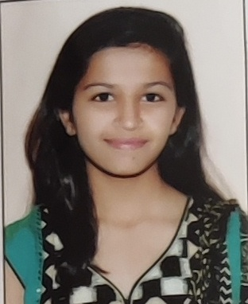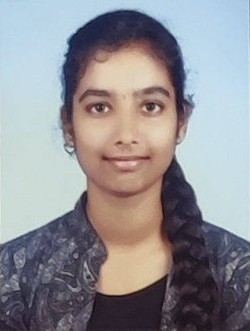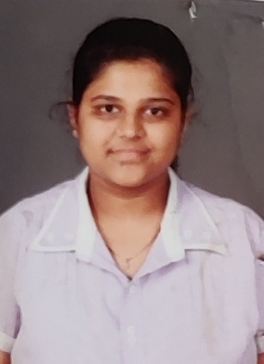

Akshatha Pasappagol Shrushti Chandralekha Patil
I Rank (89.00%) II Rank (88.60%) III Rank (88.22%)

B. COM. I SEMESTER

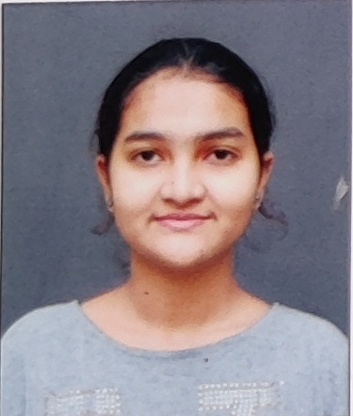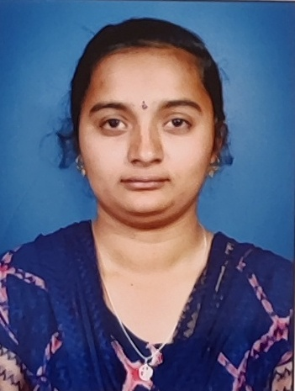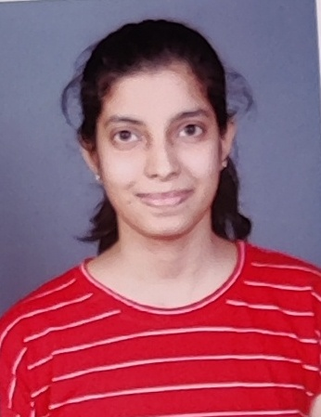

Roopa R Gosavi Rajashree S Patil Rutuja P Patil
I Rank (92.17%) II Rank (90.17%) III Rank (89.33%)

B. B. A. I SEMESTER

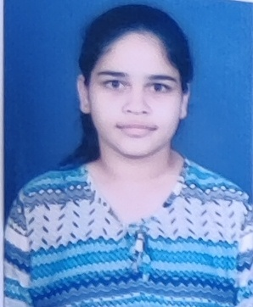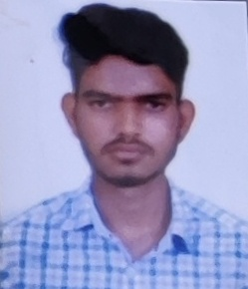

Snehal Kutre Prajakta Kumbar Anand P Shettar
I Rank (89.17%) II Rank (88.50%) III Rank (86.67%)

K.L.E. Society’s

Lingaraj College, Belagavi
(Autonomous)
Degree Examinations June/July 2021
Toppers in the B.A., B.COM, B.B.A- III Semester

B. A. III SEMESTER

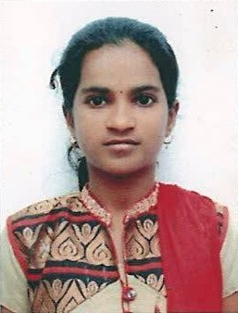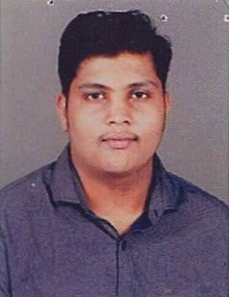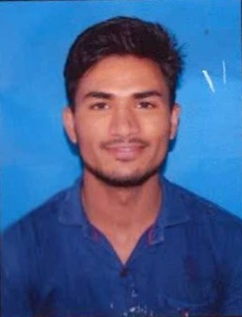
Pallavi Kori Amar Kantayya Subbapurmath Ajeet B Bagi
I Rank (94.31%) II Rank (85.08%) III Rank (83.85%)

B.COM. III SEMESTER

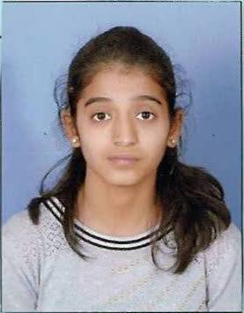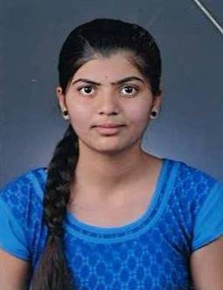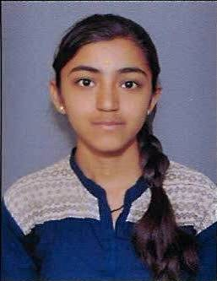

Ankita M Agarwal Vasundhara S Maroor Vaishanavi V Hiroji
I Rank (91.57%) II Rank (90.71%) III Rank (90.29%)

B.B.A. III Semester

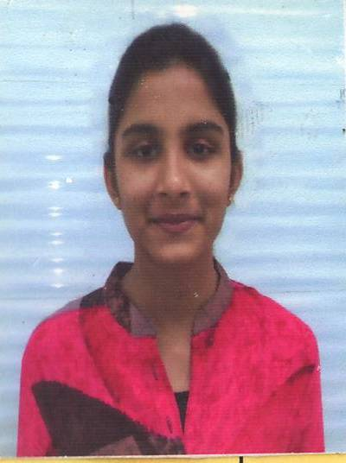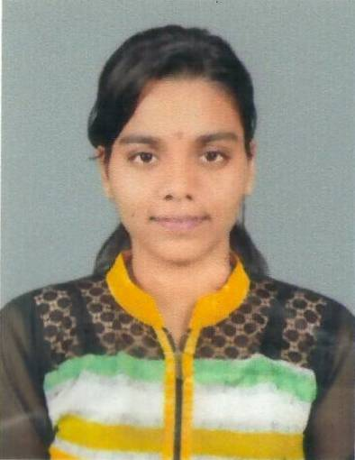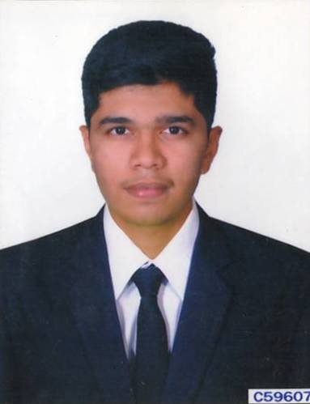

Khushi D Mehta Akshita Singh Mohammed Saaliq
I Rank (96.14%) II Rank (95.71%) III Rank (95.00%)

K.L.E. Society’s

Lingaraj College, Belagavi
(Autonomous)
Degree Examinations June/July 2021
Toppers in the B.A., B.COM, B.B.A- V Semester

B. A. V SEMESTER

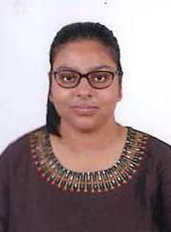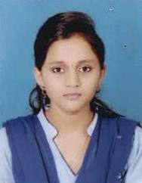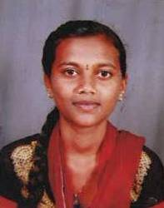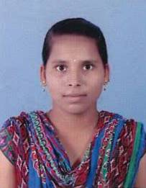
Rusha Chatterjee Supriya S Patil Akshata Mutnal Seema K Karabannavar
I Rank (88.25%) II Rank (87.00%) III Rank (86.13%) III Rank (86.13%)

B.COM. V SEMESTER

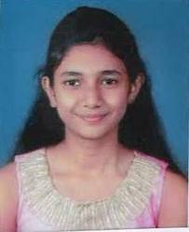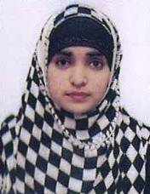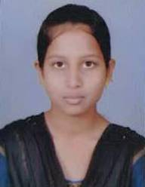
Goutami Kadolkar Barrah Soudagar Salma Aravalli
I Rank (92.14%) II Rank (91.00%) III Rank (90.29%)

B.B.A. V Semester

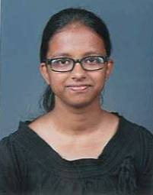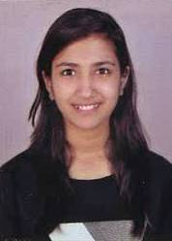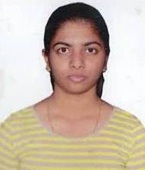

Queency Rodrigues Jyoti Shiralkar Anusha A Kalkutkar
I Rank (94.86%) II Rank (94.00%) III Rank (93.71%)

